Jacob Davis

1/29/18

STAT 330 – Homework 2

1. The response variable is the amount of prize money a golfer wins. The quantitative response variables are:
   1. Average Driving Distance
   2. Driving Accuracy
   3. GIR
   4. Putting Average
   5. Birdie Conversion
   6. Sand Saves
   7. Scrambling
   8. Bounce Back
   9. Putts Per Round

And the categorial response variable is only the tiger woods column; whether that person was Tiger Woods or not

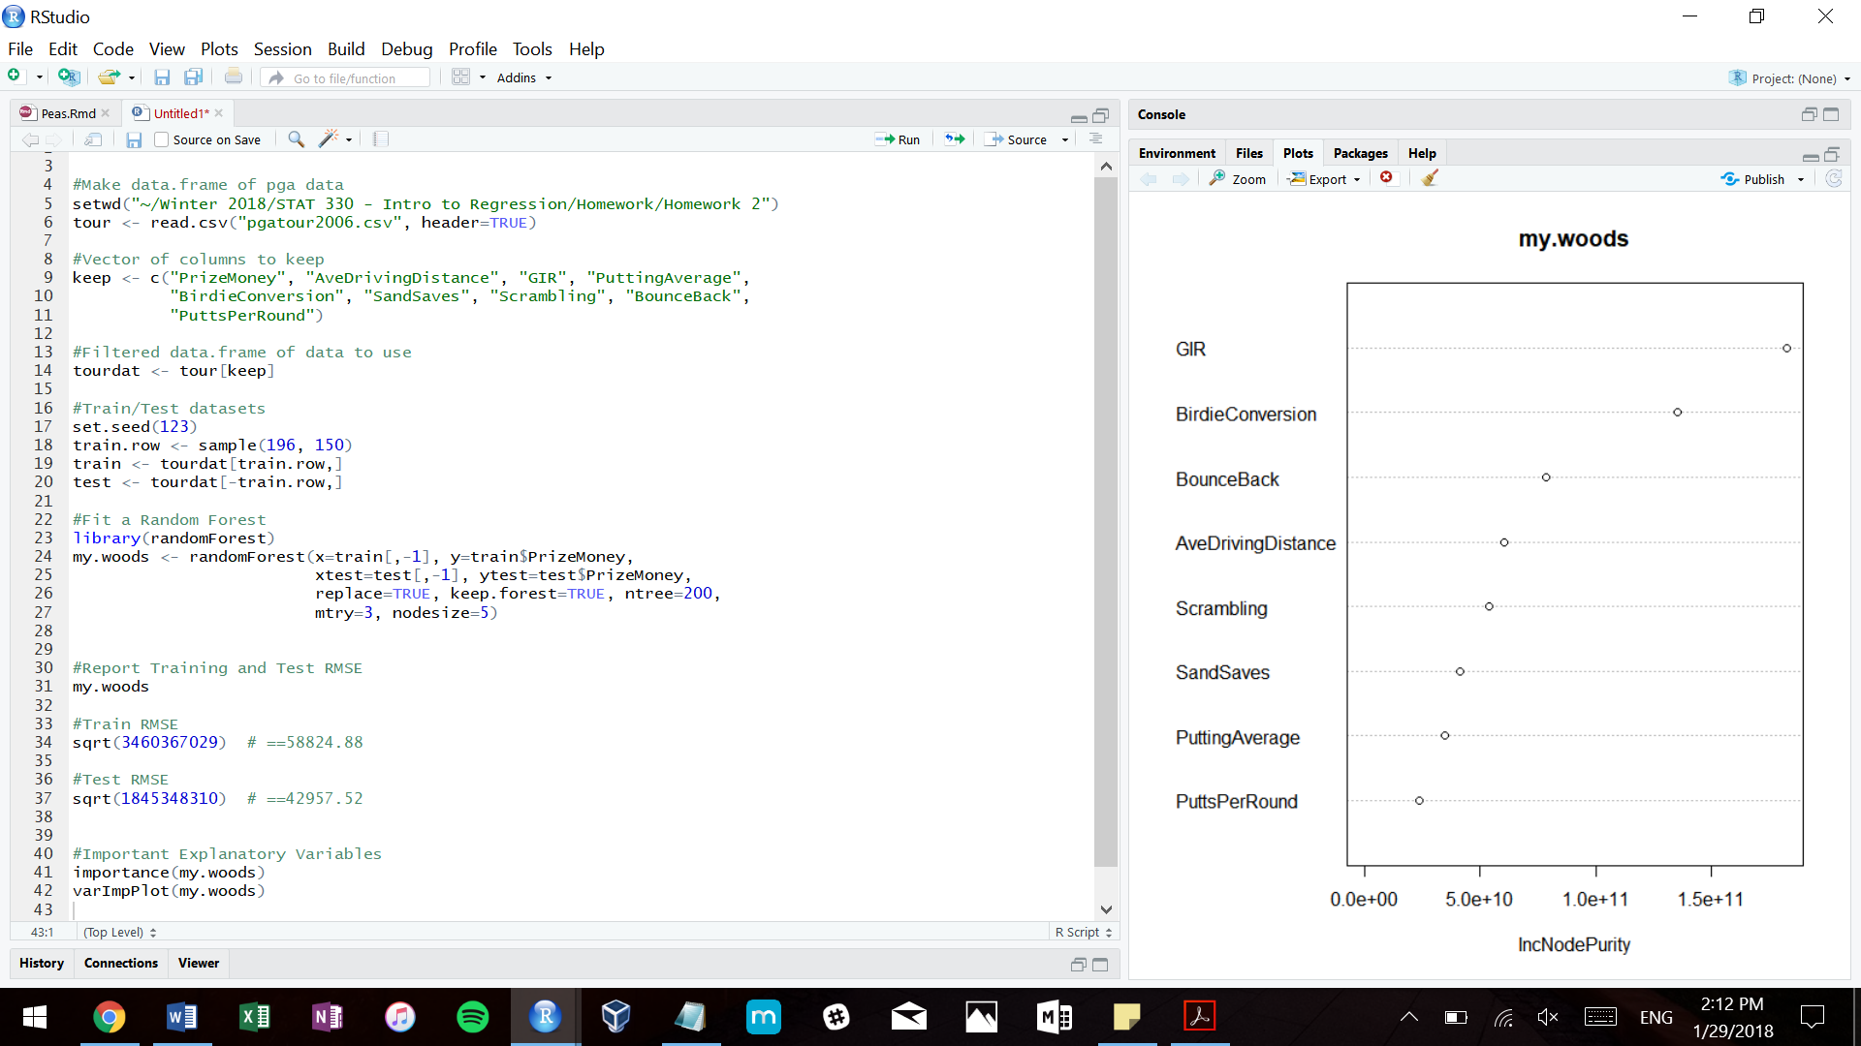

2-4

5. The three most important explanatory variables in the model are:

1. GIR

2. Birdie Conversion

3. Bounce Back

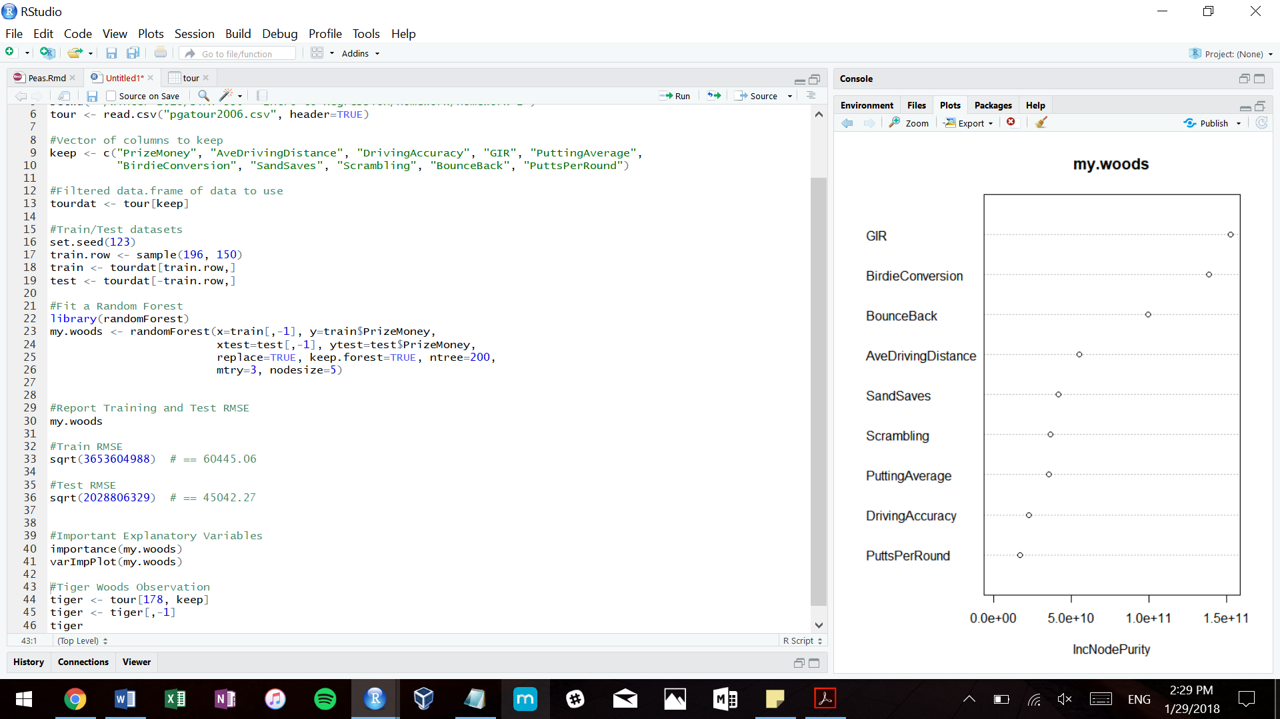

6. 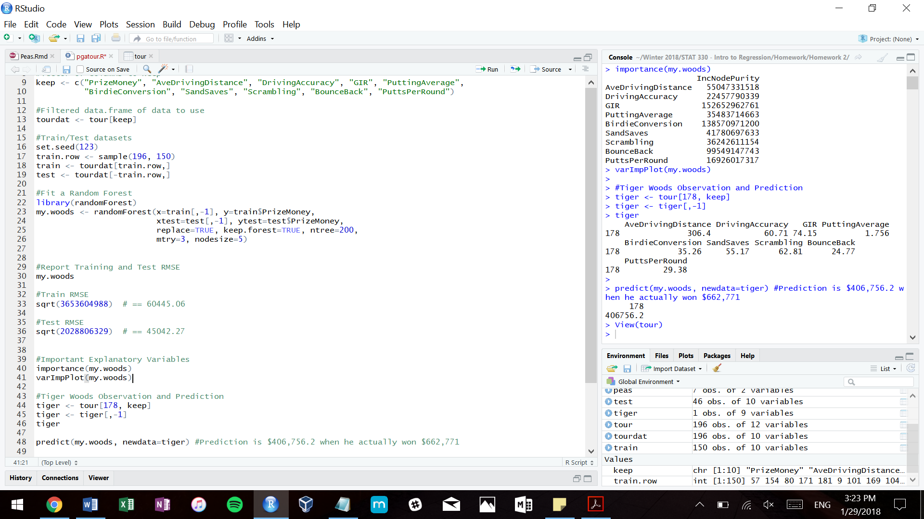

This model predicted that he would earn about $406,756, when in reality, he won $662,771, so we were still quite a way off. One reason I think there is this discrepancy is because potentially the top three or so performers could have earned additional bonuses for their performances, which wouldn’t have been taken into account.